Plan Comments Form (Buyer) |  |  |  |  |  |  |  | CONVENTIONAL ARM – T.EN
Plan Title |  | Validation of Conductix functions-Loading arm |  |  |  |  |  | PCF History
Plan No. |  | Training Center- Loading Arm |  |  | Rev No. | 0 |  | Buyer Ref. No. | Date | Maker Ref. No. | Date
Buyer’s No. |  |  |  |  | Rev No.
Drawing Status |  |  |  | Action Required
A |  |  | Approved | Revised Drawing Required |  |  | x
B |  |  | Approved subject to comments | Comments Reply Required
C |  |  | Not approved | No Further Action
R |  |  | Noted | Comment Status
 |  |  |  | Number of Open comments |  |  | xx

No. | BUYER’S PROPOSAL |  | BUYER’S INITIALS | T.EN’S CHECKING |  | STATUS
 | Communication with PLC:
1 | a) | Base Unit (type NEMO) - Possible communications with PLC:  - Profibus DP  - Profinet  - Ethernet  - CanOpen  - Modbus | CDIX |  | Communications validated by T.EN:  - Profibus DP  - In progress (test with CPU 315-2DP)  - Profinet  - Must be validated (on CPU 1516-3PN/DP)  - Ethernet NOT VALIDATED  - CanOpen NOT VALIDATED  - Modbus NOT VALIDATED | PENDING
1 | b) | Transmitter (type MOKA) – Operating distance  - Freq. 433-434 MHz / 2.4GHz  - Distance  - Radio mode: From 0 to 200 m  - Pendant mode: 30m (max) | CDIX |  | Communications validated by T.EN:  - Required frequency: 418-480 MHz Not checked  - Distance  - Radio mode Not checked  - Pendant mode Not checked | PENDING
1 | c) |  |  |  |  | PENDING
2 | a) |  | CDIX |  | Battery:  - Radio operating time?? | OPEN
2 | b) | Call Conductix – 2023 11 23  - Radio permanently linked to the base unit at 25°C  - Material ATEX & NON ATEX  - 10h |  |  | 2023 11 23  - Wait email with technical docs. | OPEN
2 | c) |  |  |  |  | OPEN
 |  | Radio functions
3 | a) | - ON / OFF Start button | CDIX | a) | - Ok – Checked by T.EN | CLOSE
3 | b) |  (no pressed) | CDIX | b) | - Picture radio OFF  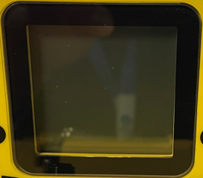 | CLOSE
3 | c) | =>  (pressed) | CDIX | c) | - Picture radio ON  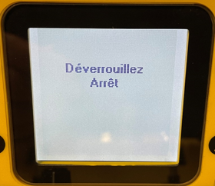 | CLOSE
4 | a) | - Indicating ON/OFF Status on screen | CDIX | a) | - NOK – Not Checked by T.EN | OPEN
4 | b) |  |  | b) | Add picture with status on screen | OPEN
4 | c) |  |  |  |  | OPEN
5 | a) | - 1 analog joystick:  - For Slewing LEFT-RIGHT  - For Outboard IN-OUT | CDIX | a) | - NOK – Not Checked by T.EN  - With deadman?? | OPEN
5 | b) | 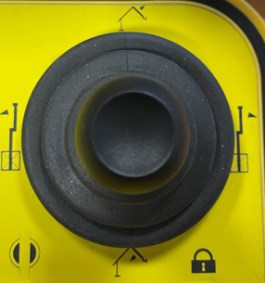 | CDIX | b) | - Picture with Slewing Left & Right  Right  Left | OPEN
5 | c) |  | CDIX | c) | - Picture with Outboard In & Out  Out  In | OPEN
6 | a) | - 1 analog joystick:  - For Inboard FORWARD-BACK  - For Coupler OPEN-CLOSED | CDIX |  | - NOK – Not Checked by T.EN  - With deadman?? | OPEN
6 | b) | 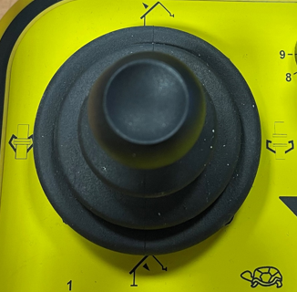 | CDIX |  | - Picture with Inboard Forward & Back  Forward  Back | OPEN
6 | c) |  | CDIX |  | - Picture with Coupler Open & Close  open  close | OPEN
7 | a) | - 1 rotary switch:  - For Arm Selection (9 positions) | CDIX |  | - OK – Checked by T.EN  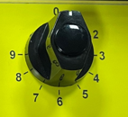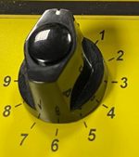 | CLOSED
7 | b) |  |  |  | Nota:  We don’t have selection for 10 arms…. | CLOSED
7 | c) |  |  |  |  | CLOSED
8 | a) | 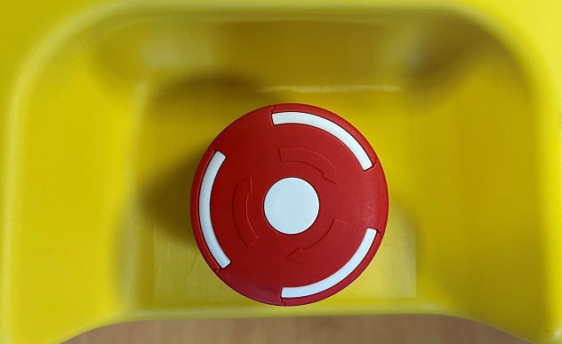  - on the right side of the radio | CDIX | a) | - Switch OFF Radio & Display  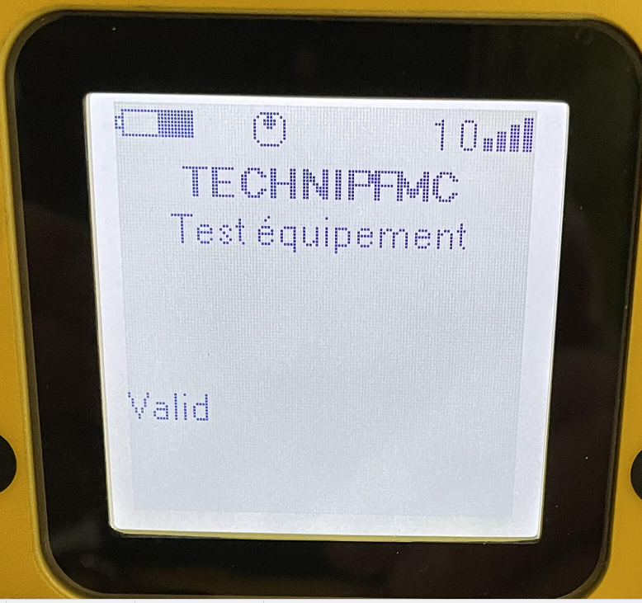 | PENDING
8 | b) | - 1 Emergency Stop button  - Switch off Radio |  | b) | Not same function like CAVOTEC push button (which stop hydraulic pump) | PENDING
8 | c) |  |  | c) | - How switch Off Radio without this button??  - This Emergency Button is used sometimes to STOP hydraulic pumps | PENDING
9 | a) | - Time to standbye | CDIX | a) | - Checked by T.EN  - Standbye time is 4 min  - Possibility to adjust this value???? | CLOSE
9 | b) | Call Conductix – 2023 11 23  - Yes. Possible to adjust with [iDialog] software  - Open [User param]  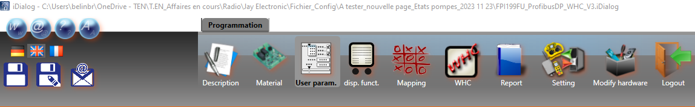  - Select [General Setting]  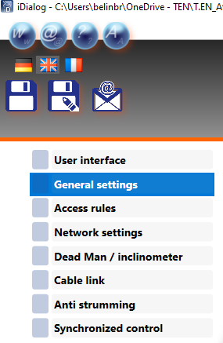  - Find [Passive Stop] option  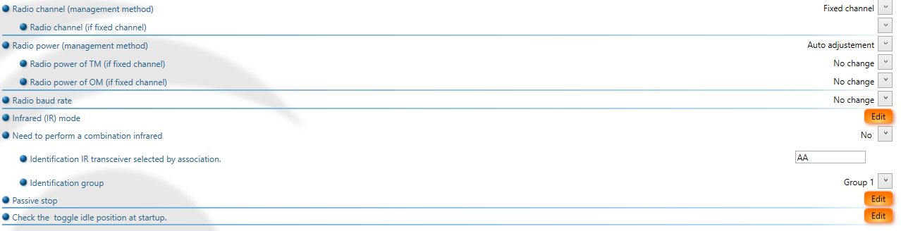  - Click on [Edit] inside [Passive Stop] line |  | b) | 2023 11 23  - Open [iDialog v5.3]  - Open [User param]  - Select [General Setting]  - Find [Passive Stop] option  - Click on [Edit]at the end of [Passive Stop] line  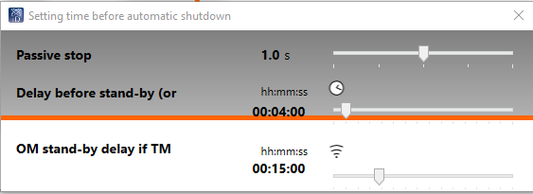 | CLOSE
9 | c) |  |  | c) | - Check standbye time on CAVOTEC | CLOSE
10 | a) | - DBV Open/Close command | CDIX | a) | - Checked by T.EN | CLOSE
10 | b) | - Add pictures |  | b) | - Add pictures | CLOSE
10 | c) |  |  | c) |  | CLOSE
11 | a) | Display on Radio | CDIX | a) |  | CLOSE
11 | b) | - Display 1 arm in state: |  | b) | - Checked by T.EN | CLOSE
11 | c) | - No selected  - Selected  - Locked |  | c) | - Add pictures with switch position and display | CLOSE
12 | a) | - Display 4 arms in state: | CDIX | a) | - Not Checked by T.EN | PENDING
12 | b) | - No selected  - Selected  - Locked |  | b) | - Tests each status for each arms | PENDING
12 | c) |  |  | c) |  | PENDING
13 | a) |  | CDIX | a) | - Communication radio fault  - Lost Radio information “Status: Présence Radio Réception  - Checked by T.EN  - How to solve it? | OPEN
13 | b) | Call Conductix – 2023 11 23  - Try with new variable: State TM  - And Boolean system 1Hz in serial |  | b) | 2023 11 23  - Must test with new variable: State TM [E1109.0]  - AND Boolean 1Hz [E1109.3]  - State TM and NOT Boolean 1Hz = communication fault | OPEN
13 | c) |  |  | c) |  | OPEN
14 | a) |  | CDIX | a) | Possible to add texts for hydraulic pump state:  - Pump Stop  - Pump Running | OPEN
14 | b) | Call Conductix – 2023 11 23  - Yes. Create new page with [iDialog] software  - Prepare new information to displayed  - Bit Num02 = 1 => STOP POMPE  - Bit Num02 = 2 => MARCHE POMPE |  | b) | 2023 11 23  - New page created  - New texts are ready inside iDialog config file (FPI199FU_ProfibusDP_WHC_V3)  - MUST be load in radio | OPEN
14 | c) |  |  | c) |  | OPEN
15 | a) | - Remove battery on Radio | CDIX | a) | - Checked by T.EN | CLOSE
15 | b) |  |  | b) | - Fault Radio on LCP | CLOSE
15 | c) |  |  | c) |  | CLOSE
16 | a) |  | CDIX | a) |  | OPEN
16 | b) |  |  | b) |  | OPEN
16 | c) |  |  | c) |  | OPEN
17 | a) |  | CDIX | a) |  | OPEN
17 | b) |  |  | b) |  | OPEN
17 | c) |  |  | c) |  | OPEN
18 | a) |  | CDIX | a) |  | OPEN
18 | b) |  |  | b) |  | OPEN
18 | c) |  |  | c) |  | OPEN

